
Machine Learning in Action: Performance Metrics and Ethical Reflection on Iris Classification

Payman Ghorbani 12700830

Launching into Computing

University of Essex Online

12 September 2025

Dr. Samuel Danso

Contents
Contents 2
Table of Figures 3
1. Analyse a hypothetical business scenario where an enterprise is facing cybersecurity challenges (e.g., phishing 4
Conduct a threat assessment to identify the potential vulnerabilities in the system. 4
Key Risk Management Strategies: 4
Propose a mitigation plan, which includes: 5
References 8
Appendices 9
Appendix A: Model Evaluation Metrics with random_state = 1 9
Appendix B: Model Evaluation Metrics with random_state = 42 11

Table of Figures
Figure 1-Screenshot of model performance metrics using random_state=1, showing non-perfect scores for accuracy, precision, recall, and F1. 7
Figure 2- Screenshot of model performance metrics using random_state=42, showing perfect scores across all evaluation metrics. 9

Cybersecurity and Risk Management in Computing course
https://www.my-course.co.uk/mod/scorm/player.php?a=20164&currentorg=articulate_rise&scoid=40407&sesskey=Cldfzu4Zep&display=popup&mode=normal

Understanding these cyber threats and attack vectors is essential for developing effective defence strategies. Organisations must implement firewalls, encryption, and multi-factor authentication to protect their systems, while individuals should remain vigilant against phishing scams and suspicious online activities.
- Analyse a hypothetical business scenario where an enterprise is facing cybersecurity challenges (e.g., phishing attacks, ransomware threats, or cloud security vulnerabilities).

Conduct a threat assessment to identify the potential vulnerabilities in the system.
Risk management is a critical aspect of cybersecurity, helping organisations identify, assess, and mitigate potential threats to their IT infrastructure. Without a well-structured risk management strategy, businesses may face financial losses, data breaches, and operational disruptions.

Key Risk Management Strategies:

Risk Assessment
1- The first step in risk management is risk assessment, where organisations identify assets that need protection, such as sensitive data, financial records, and proprietary software. Security teams analyse potential threats and vulnerabilities that could compromise these assets.
Banks conduct risk assessments regularly to protect against financial fraud.
“By adopting structured risk management strategies, organisations can proactively protect their IT environments and reduce the likelihood of security breaches.”
Source: Container Journal. (2023). “Best Containerization Tools of 2023.” Retrieved from https://containerjournal.com/tools/best-containerization-tools/

2 Risk Mitigation
Once risks are identified, organisations develop risk mitigation strategies to reduce their impact. This includes implementing security controls such as access restrictions, network segmentation, and regular security updates.
Risk mitigation also involves employee training programs to raise awareness about cyber threats, such as phishing scams and social engineering attacks.

3 Risk Monitoring
Risk management also includes risk monitoring, where organisations continuously track security threats and adjust their defences accordingly.
Automated monitoring tools help detect anomalies in network traffic, flagging potential attacks before they cause damage.

4 Incident Response Plan
An essential component of IT risk management is the incident response plan, which outlines how an organisation should react in the event of a cyberattack.
The plan defines roles and responsibilities, escalation procedures, and recovery steps to minimise downtime and data loss.

Propose a mitigation plan, which includes:

Risk Mitigation
Once risks are identified (risk assessment is done), organisations develop risk mitigation strategies to reduce their impact. This includes implementing security controls such as access restrictions, network segmentation, and regular security updates.
Risk mitigation also involves employee training programs to raise awareness about cyber threats, such as phishing scams and social engineering attacks.

-Recommended security protocols (e.g., firewalls, multi-factor authentication).
-Encryption techniques for data protection.

Risk Momitoring
Risk management also includes risk monitoring, where organisations continuously track security threats and adjust their defences accordingly.
Automated monitoring tools help detect anomalies in network traffic, flagging potential attacks before they cause damage.

“”””To defend against cyber threats, organisations use a variety of cybersecurity tools and defence mechanisms to protect their systems, networks, and data. These tools help prevent unauthorised access, detect malicious activities, and respond to security incidents effectively. By implementing these cybersecurity tools and defence mechanisms, organisations can significantly reduce their risk exposure and improve their ability to respond to security threats effectively
Firewalls monitor and control incoming and outgoing traffic based on predefined security rules, blocking malicious access attempts.
encryption, which protects sensitive information by converting it into unreadable code that can only be decrypted with a secure key.
Antivirus and endpoint protection software help detect and remove malware from individual devices.
Multi-Factor Authentication (MFA) adds an extra layer of security by requiring users to verify their identity using multiple factors, such as a password and a temporary code sent to their mobile device. This significantly reduces the risk of unauthorised access, even if a password is compromised.
Intrusion Detection System (IDS), which monitors network traffic for signs of suspicious activity. When a potential threat is detected, the system alerts security teams, allowing them to investigate and respond quickly.
Security Information and Event Management (SIEM) systems, which collect and analyse security data from multiple sources to detect patterns of potential cyber threats. These systems provide real-time monitoring and automated responses to security incidents.

5 Compliance considerations for regulations like GDPR or ISO/IEC 27001.
Financial institutions, healthcare providers, and government agencies rely on risk management frameworks such as ISO 27001, NIST Cybersecurity Framework, and COBIT to ensure their security measures align with industry standards.
Source: Container Journal. (2023). “Best Containerization Tools of 2023.” Retrieved from https://containerjournal.com/tools/best-containerization-tools/

References

Anaconda (2024) Anaconda Assistant Documentation. Available at: https://docs.anaconda.com/assistant (Accessed: 12 September 2025).
Fisher, R.A. (1936) ‘The use of multiple measurements in taxonomic problems’, Annals of Eugenics, 7(2), pp.179–188.
Han, J., Kamber, M. and Pei, J. (2012) Data Mining: Concepts and Techniques. 3rd edn. Amsterdam: Elsevier.
Manure, A., Bengani, S. and Saravanan, S. (2023) Introduction to Responsible AI: Implement Ethical AI Using Python. Apress. Available at: https://learning.oreilly.com/library/view/introduction-to-responsible/9781484299821/html/611333_1_En_1_Chapter.xhtml (Accessed: 12 September 2025).
Mehrabi, N., Morstatter, F., Saxena, N., Lerman, K. and Galstyan, A. (2021) ‘A survey on bias and fairness in machine learning’, ACM Computing Surveys, 54(6), pp.1–35.

Appendices

Appendix A: Model Evaluation Metrics with random_state = 1

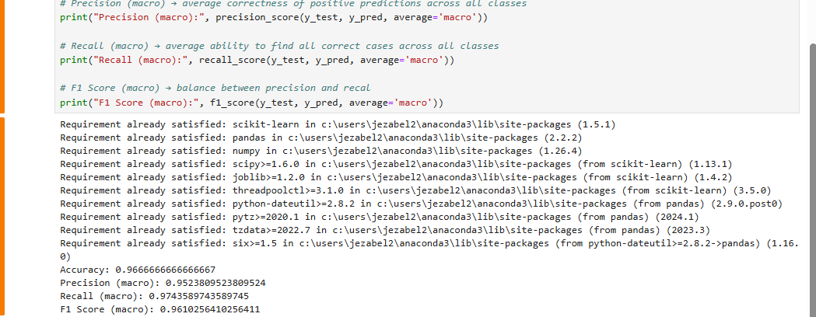
Figure 1-Screenshot of model performance metrics using random_state=1, showing non-perfect scores for accuracy, precision, recall, and F1.

Appendix B: Model Evaluation Metrics with random_state = 42

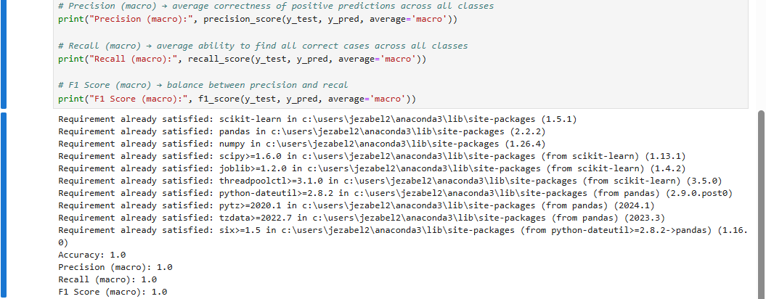
Figure 2- Screenshot of model performance metrics using random_state=42, showing perfect scores across all evaluation metrics.

